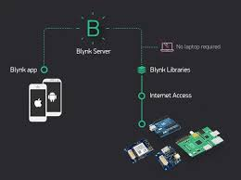The Pet Feeder

A simple IOT solution to manual pet feeding,

Using motion detection and distance tracking.

**Physical Build:**

* 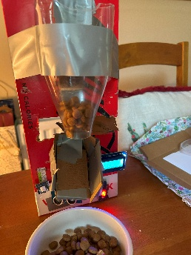Multiple iterations:
* Built on a **Raspberry Pi** with components from the **Grove Base Kit**.
* 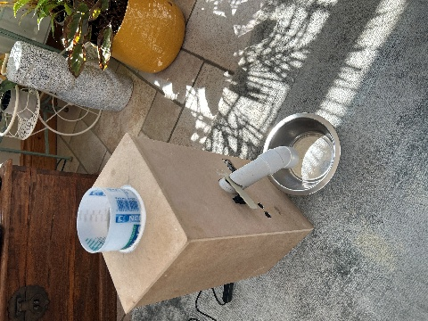Features include:
  + **Servo motor–based flap**
  + **Buzzer and LED indicators**
  + **LCD screen for feedback**
  + All hardware fitted into a custom cardboard prototype enclosure.

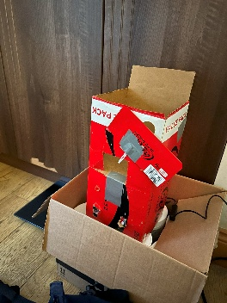 **💡 Key Features**

**Sensor-driven Feeding Logic**: Uses a **PIR motion sensor** and **ultrasonic sensor** to detect when a pet approaches.

* **Adaptive Feeding**:
  + First detection triggers a **main feed** with a servo-controlled flap and LED + buzzer sequence.
  + Subsequent detection after cooldown triggers a **smaller top-up feed**.
* **Cloud Telemetry**:
  + Sends real-time **JSON telemetry** (timestamp, motion, distance) to **Azure IoT Hub** via **MQTT**.

**User Interface**: **BLynk mobile app** allows remote enabling/disabling of the feeder and live data monitoring (motion + distance).On-device **LCD display** shows system status and sensor values in real-time.